Our proposal focuses on the solution architecture, screen displays and the workflow related to the AtMeeting application. Atmeeting application is a web-based application is a web-based that tablets and other handheld to be used “at the meeting” to manage meeting related activities to improve the local event, reduce the work load for the meeting facilitators, and promote IEEE member engagement. The application proposal addresses the security level both at physical level and at safety in the virtual web world.

Initially, the IEEE representative would welcome the attendees. At the entrance the IEEE representative would have a handheld device and if the attendee is preregistered for the meeting, he would be required to enter his email on the handheld device. In case, if the email the address entered by the user is not right then, the user would be redirected to the same page where the application would ask the user to re-enter the login details again. If the user is an existing IEEE member but has not registered for the meeting, the user would be provided with the facility to register for the meeting instantly. At this point, the application on the handheld device would pull the information about the attendee from IEEE database also user would be able to update any personal information (only address and phone number, not name or DOB), if required. On the same page there would be two conditional check boxes, which would only exists if the attendee is not an IEEE member and/or he wants the copy of the facilitator’s presentation, this box would exist only if the facilitator agrees for the distribution of his presentation. This page would consist of a button for the confirmation of the details which would be pressed by the user. After the email verification, the attendee would be required to hand the device back to IEEE representative for further identity verification. At the moment the IEEE representative would be rendered with a new page which would contain the name of the attendee and the date of birth. The IEEE representative would then match the date of birth on the DL with that on the web page and hit the confirm identity button. The confirm button on the application would upload the information on the webserver, store it in the device itself, and on the local database/cloud. The information about the name of the attendees, if he/she is a new member and his new elevations would be send to the facilitator of the meeting via the application, this would be done simultaneous while save the data on the hit of the confirm identity button by the IEEE representative. The facilitator would be able to print the detail if required. To make the information easily viewable for the facilitator, the rendered page for the facilitator would consist of three columns, namely “Attendee”, which would contain the name of the attendees, “New Member”, this would have a check mark if the meeting attendee is a new IEEE member or is new to the region, and the column for “Recent Accomplishments” or “New Elevation”. The entire process would take in consideration the security web security threats (Fig.1). This implementation also takes in the physical security of the IEEE meeting since no one without the identification would be able to enter the meeting. This application would be able to run on any device since it would entirely be based on web browsers which can be detected by the process show below

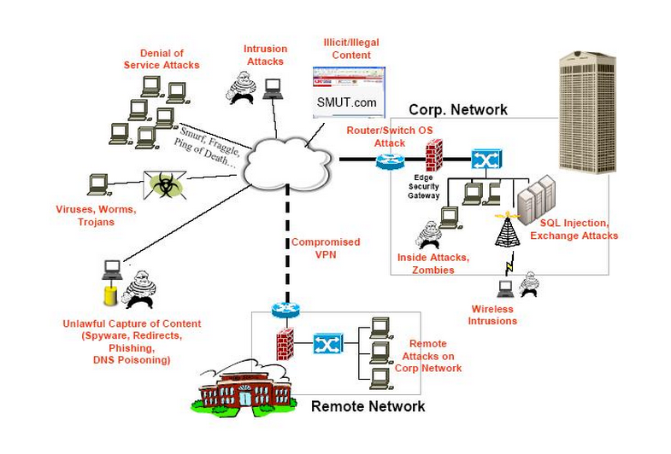

Fig.1 Security Threats which would be addressed for the Application

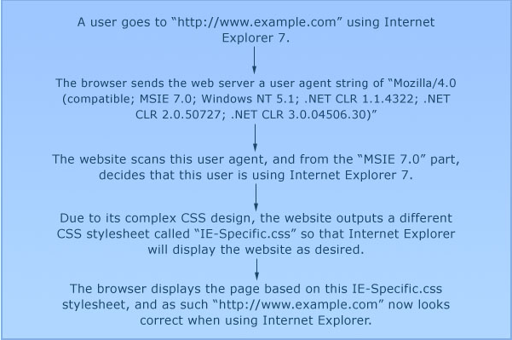

Fig.2 Browser Detection Process.

This process of development would be broken down into three parts for implementation, namely

1. Webpage Development with CSS
2. Scripting with Security Concerns
3. Database Handling

The table below shows the require man hours for complete implementation of the design (table1). It has been assumed that IEEE would handle its part of the program for the implementation of the complete design.

Table 1 Project Implementation

|  |  |
| --- | --- |
| **PROCESS** | **MAN-HOURS** |
| Webpage Development with CSS | 2x40hr |
| Scripting with Security | 4x40hr |
| Database Handling | 4x20hr |

**REFERENCES**

Images by courtesy of Google.